SAFARI TOOBS
Safari Ltd TOOBS are collections of individually hand painted miniature replicas featuring vibrant colours, professional sculpting, and accurate detail. They are available in dozens of themes, and each set of figures comes in a reusable acetate tube that snaps open and closed for easy storage. The tube also has a spinning globe on its cap. TOOBS are perfect for educational projects, traveling, collecting, and imaginative play.
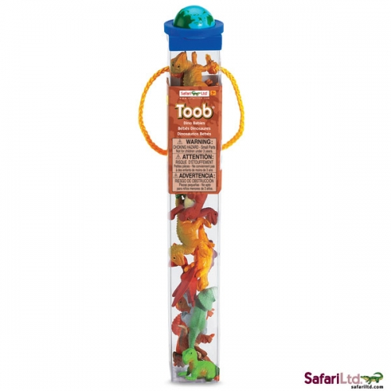
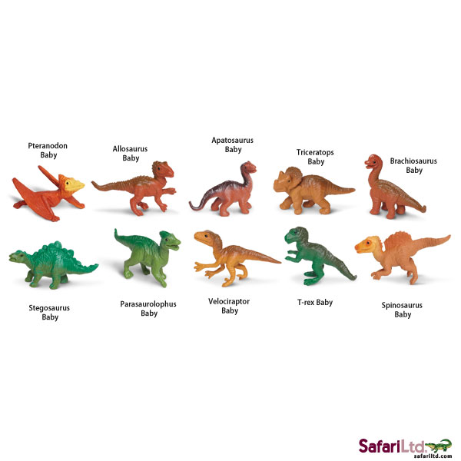
SF680104 – Dino Babies Toob
Even dinosaurs can be cute when they are in our Dino Babies TOOB®. Safari Ltd® TOOBS® are collections of individually hand painted miniature replicas featuring vibrant colors, fine, professional sculpting, and accurate detail. They are available in dozens of themes, and each set comes in a reusable acetate tube that snaps open and closed for easy storage. The tube also has a spinning globe on its cap. TOOBS® are perfect for educational projects, traveling, collecting, and imaginative play.
Dino Babies TOOB® Contains: Pteranodon Baby, Allosaurus Baby, Apatosaurus Baby, Triceratops Baby, Brachiosaurus Baby, Stegosaurus Baby, Parasaurolophus Baby, Velociraptor Baby,T-Rex Baby, Spinosaurus Baby
Replicas Measure 4 to 7.5 cm
Recommended Age 3+
Product Information
Product Code | Description | Contents | Length (cm) | Width (cm) | Depth (cm) | Weight (Kg) | Carton Qty | GTIN / EAN
SF680104 | Dino Babies Toob | 10 pcs | 4 | 33 | 4 | 1.69 | 48 | 10095866695405

